**BA701**

**Analytic Lifecycle Management**

**Report**

**Final Assignment**

**Instructor: Mustafa Ahmed**

**Campus: Progress**

**Done By:**

* **Alester Joshua D Costa (301321745)**
* **Jason Yap (301293413)**
* **Khawja Nayeem Ather (301187396)**

**Table of Contents**

1. Executive Summary 3

1.1. Introduction 3

1.2. Purpose 3

2. Methodology 4

2.1. Data Collection 4

2.2. Data Integration and transformation 5

2.3. Data Characterization 5

2.4. Data Sensemaking 5

3. Customer Profiling 6

3.1. Chart 1 6

3.2. Chart 2 7

4. Customer Experience Insights 8

4.1. Chart 3 8

4.2. Chart 4 9

4.3. Chart 5 10

5. Recommendations 11

5.1. Recommendations based on customer reviews 11

5.2. Future opportunities 12

6. References 13

# Executive Summary

## 1.1. Introduction

La Veranda Hotel is a three-star hotel located in Larnaca, Cyprus, that is situated 2.4 km from the Church of Agios Lazaros and a 3-minute drive from Larnaca International Airport (iBooked, 2023, Overview section, para. 1). The hotel provides 30 air-conditioned guest rooms with free wireless internet, a cable flat-screen TV, a coffee maker, and a mini-bar that is furnished with a wardrobe, and a balcony with an average rate of $80.00 per night (iBooked, 2023, Rooms section, para. 3). La Veranda Hotel received an average rating of 8.8 out of 10 reviews at iBooked, 9.4 out of 10 at Expedia, and 9.2 out of 10 at Trivago, indicating the high-quality services provided to its customers (iBooked, 2023; Expedia, 2023, Trivago, 2023).

Regardless of being a 3-star hotel with an excellent average rating of 9.1 among three booking or travel platforms, La Veranda still faces issues and receives negative reviews when providing the relevant services to its customers. Out of 1,114 reviews, 30% contain unfavorable feedback related to either customer expectations or hotel experiences. Unfavorable feedback if left unattended could damage the owner and hotel’s reputation overtime that will impact the hotel’s revenue and in turn affect the hotel’s staff such as Housekeeping, Food, Maintenance, Administration, Marketing, and such others.

## 1.2. Purpose

The purpose of this study is to “*use data-driven insights to enhance Le Veranda’s customer service, improving the hotel’s reputation and ensuring customer satisfaction*” by proposing recommendations. The stakeholders who are part of the customer review analysis of Le Veranda is described by the following table:

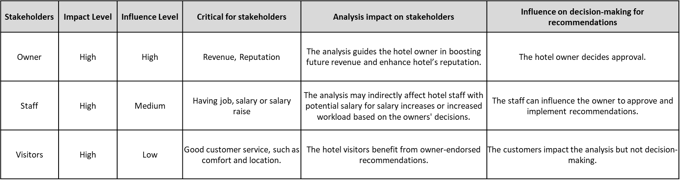

# Methodology

This Natural Language Processing (NLP) analysis aims to provide insights and recommendations for enhancing La Veranda Hotel's customer service, reputation, and overall customer satisfaction. The analysis is constrained by the dataset's source, which includes data from social sites, travel or hotel platforms, and analytics websites. Furthermore, the sample size is limited to visitors who have provided reviews from a Kaggle dataset. The primary focus of this report is to leverage customer review data to enhance La Veranda's organizational performance. The executive summary section outlines the challenge of unfavorable reviews despite the hotel's high average rating. In the subsequent sections this study will explore strategies for improving customer satisfaction by using sentiment analysis to understand the customer experience.

To conduct sentiment analysis, an NLP model was employed within Microsoft Excel to categorize text data into positive or negative sentiments. While the analysis offers valuable insights into sentiment, it's important to acknowledge potential model limitations and biases.

## 2.1. Data Collection

The data source that has been chosen to comprehend customer reviews of Le Veranda Hotel has been extracted from Kaggle. Hatab (2023) highlights that the data present in the hotel dataset is originally owned by Booking.com, a globally known travel agency known for providing data and insights to improve property sales and enhance bookings. As part of its platform, Booking.com provides an analytics functionality to access business reports with real-time information to oversee past and future sales of a hotel, along with comparing performance against the competition (Booking.com, 2023, Understanding your Analytics space section, para. 2). In this regard, the data set generated by Booking.com about Le Veranda’s customer reviews comprises of approximately 1523 customer reviews; the data was extracted precisely one year after the hotel commenced its operations. This also serves as a limitation as the study included only one year's worth of data. The figure of 1523 customer reviews also include empty values and other forms of data inconsistency which has been addressed in the next sub-section of data integration and transformation.

## 2.2. Data Integration and transformation

The customer review dataset from Le Veranda Hotel, Larnaca, Cyprus, was consolidated into a single Excel file. Upon review, data inconsistencies and errors were identified, such as unclear special characters, misclassified positive/negative reviews, and irrelevant data. Using Excel's filter and PivotTable functionalities, the dataset was cleaned, reducing the rows from 1523 to 784 for customers who provided written reviews. Additional columns were added to facilitate NLP analysis for a deeper understanding of customer preferences and feedback.

## 2.3. Data Characterization

The customer ratings have been divided based on a 5-point Likert scale, ranging from ‘Very Dissatisfied’ to ‘Very Satisfied’. The data concerning visitor reviews is based on customer reviews primarily on five factors: room, staff, location, price, and food. Keywords were taken from both positive and negative reviews based on the five factors encompassing Le Veranda’s services.

## 2.4. Data Sensemaking

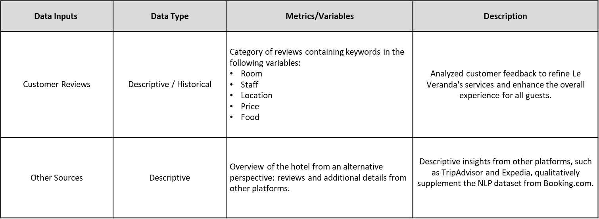The intent of data sensemaking is to comprehensively understand the problem and derive insights from complex and often unstructured data. It helps individuals or organizations to interpret data, uncover patterns and make informed decisions based on the information obtained from data analysis. The table below depicts key metrics/variables used for two data inputs.

# Customer Profiling

A customer profile is used to identify and understand the characteristics and preferences of a specific market or segment. As part of the customer profiling, a detailed and comprehensive profile of the ideal customer or market segment that Le Veranda wants to reach is created.

## 3.1. Chart 1

Chart 1 shows that most of the visitors came from Western Europe which are mostly from France (59), Germany (48), and Italy (19). followed by the Middle East which are mostly from Israel (77), Cyprus (72), and Lebanon (23). The data shows that there is an opportunity to expand influence in Western Europe, Northern Europe and the Middle East.

## 3.2. Chart 2

Chart 2 shows that most tourists at 73% prefer to travel in groups or with others. Couples are the most prevalent group type, accounting for 34% of all visitors, followed closely by families at 29%. According to the research, social or group travel is a popular choice among travelers, with couples being the most common category within this group, showing a propensity for shared travel experiences.

# Customer Experience Insights

The dataset on Le Veranda’s customer reviews includes guest experience on a 5-point Likert-scale, and positive and negative reviews provided by visitors based on five categories: room, staff, location, price, and food.

## 4.1. Chart 3

Chart 3 illustrates that even though many visitors are satisfied with Le Veranda’s services, 9 out of 784 guests have an unfavorable opinion on Le Veranda’s services; this comprises of 2 visitors who are “very dissatisfied” with Le Veranda’s services and 7 visitors who are “dissatisfied” with Le Veranda’s services. Le Verenda has an average customer review of 9.04; nonetheless, upon closer inspection, it has been found that customers in the “neutral”, “satisfied”, “very satisfied” categories have also provided negative feedback on the services offered by Le Veranda.

## 4.2. Chart 4

Chart 4 depicts the positive customer reviews of Le Veranda according to five categories: room, staff, location, price, and food. As part of these categories, several keywords have been extracted to formulate meaningful insights. The following points highlight the insights from the positive reviews provided by customers:

* **Staff (31%):** The term “friendly” was used 178 times, emphasizing the significance of the hotel staff's friendliness in guests' positive experiences. The friendliness of the hotel staff is the most significant factor contributing to positive reviews, with a dominant 31% share.
* **Location (24%):** The hotel's proximity to the beach and the airport is highly appreciated by guests, with 62 mentions of the word “beach” and 74 mentions of the term “nearby airport”. The hotel's prime location near the beach and airport is a major selling point, regularly admired in positive reviews.
* **Room (23%):** Guests consistently praise room cleanliness, with the word “clean” mentioned 188 times, highlighting the importance of maintaining high standards. Room cleanliness remains a priority for guests, highlighting the importance of maintaining such services.
* **Food (17%):** Positive reviews often mention food quality, with terms like “good” and “excellent” used over 10 times. The favorable mentions of food quality emphasize the hotel's strong culinary offerings.
* **Price (5%):** Positive reviews also note the hotel's pricing through the words “reasonable” and “affordable”. The favorable references to the hotel’s pricing also contribute to guests' satisfaction.

## 4.3. Chart 5

Like the positive reviews, Chart 5 illustrates the negative customer reviews on Le Veranda according to five categories: room, staff, location, price, and food. The observations and insights have been described by the following points:

* **Room (52%):** Negative reviews mention issues related to the room, particularly concerning the term "bathroom smell," which was specified in 6 reviews. Room-related concerns make up most of the negative feedback.
* **Food (17%):** Food-related concerns are significant in negative reviews, with mentions of "limited options" occurring twice. Guests express dissatisfaction with the food offerings.
* **Location (14%):** Some negative reviews cite issues with the hotel's proximity to the "city center," which was mentioned 3 times.
* **Price (9%):** Negative comments related to pricing, with the term "high" mentioned 5 times, indicating that some guests find the hotel's pricing to be a concern.
* **Staff (8%):** Negative reviews sometimes touch on issues related to "communication," which has been referenced 4 times. Although it makes up a smaller percentage, it is still a notable aspect of customer dissatisfaction.

# Recommendations

## 5.1. Recommendations based on customer reviews

Based on the data that has been analyzed from the customer reviews of Le Veranda’s services, i.e., room, staff, location, price, and food, it is critical to ensure that the negative reviews provided by visitors are considered. In this context, Le Veranda would be able to improve its sales and increase the number of visitors who may be interested in utilizing the hotel’s services. Consequently, the following elements are the possible recommendations to enhance each of Le Veranda’s services:

**Room**

1. **Cleanliness Standards:** Maintain high standards of room cleanliness by focusing on eliminating issues like "bathroom smell," which can significantly impact guest satisfaction. This may involve enhancing ventilation and ensuring rooms are odor-free.

**Staff**

1. **Staff Friendliness:** Continue to prioritize and promote the friendliness of the staff, as it is a significant factor contributing to positive guest experiences. Staff should maintain a warm and accommodating attitude.
2. **Communication enhancement:** Work on improving communication with guests to address concerns related to "communication" mentioned in some negative reviews. Ensure clear and effective communication channels and staff training in this area.

**Location**

1. **Invest in Marketing:** Leverage the hotel's prime location near the beach and airport as a major selling point. Consider emphasizing this advantage in marketing efforts to attract more guests.
2. **Location Clarity:** If there are concerns about the hotel's proximity to the "city center", provide clear information about its location and what guests can expect, including any transportation options to the city center.

**Price**

1. **Competitive Pricing:** Continue to offer 'Reasonable' and 'Affordable' pricing, making sure that pricing aligns with the perceived value.
2. **Transparency:** Address concerns about pricing, especially perceptions of it being "high." Ensure that pricing is transparent and justifiable based on the services and amenities provided.

**Food**

1. **Culinary Excellence and Food Variety:** Sustain the quality of the culinary offerings, as guests highly appreciate the food quality. Address the issue of ‘limited options’ by diversifying the food menu to cater to various preferences.

## 5.2. Future opportunities

1. **Create Specialized Promotions:** Develop promotionstargeted towards couples, families or visitors from specific countries, especially from North America, Eastern Europe and Northwest Europe. In addition, Le Veranda should keep providing a consistent service to visitors from the Middle East, Western Europe and Northern Europe as they account for the highest revenue from the hotel.

# References

Booking.com. (2023). La Veranda Hotel – Larnaca. https://la-veranda-hotel-larnaca.ibooked.ca/

Booking.com. (2023). Understanding your Analytics space. https://partner.booking.com/en-gb/help/growing-your-business/analytics-reports/understanding-your-analytics-space

Expedia. (2023). La Veranda Hotel. https://www.expedia.ca/Larnaca-Hotels-La-Veranda-Hotel.h55185974.Hotel-Information.

Hatab, M. (2023). *Hotel Reviews Booking.com: Reviews for an hotel in Larnaca-Cyprus.*https://www.kaggle.com/datasets/michelhatab/hotel-reviews-bookingcom

iBooked. (2023). La Veranda Hotel - Larnaca. https://la-veranda-hotel-larnaca.ibooked.ca/

Trivago. (2023). La Veranda Hotel (Larnaca, Cyprus). https://www.trivago.ca/en-CA/oar/la-veranda-hotel-larnaca?search=100-22209698